**Animation Engine Documentation**

Rob, Becky, Zach, Elliot and Chris Chan

Key concept and ideas

In a group of five, we set out to create a simple, user friendly animation engine which would allow people an introduction to both animation and coding by inputting their own images into the engine to create a moving animation.  
In our ambition to create an animation engine, as a group, we set our main focus on simplicity and user friendliness. After a short amount of time brainstorming, we decided the easiest way to achieve a user friendly animation engine was to create the engine using javascript within a HTML webpage.   
  
The engine is built around a series of questions posed to the user and allows the user to select pre designed backgrounds, characters and other objects designed by our animator within photoshop. These images can also be edited within their photoshop documents, should the user wish to create their own objects, but not have enough knowledge to build these scenes from scratch.

The flexibility of the form type animation engine, varies, allowing people with a higher knowledge of coding and animation to add their own images and possible pathing, whilst keeping the simple elements and pre selected lists allow users with little knowledge the same power to build their own animation.

Features of the engine

The features of the animation engine allow for a simple selection or input of images and characters which can then be used, these images can be ones chosen from a preset that has been designed by our animator, or can be ones that the user would like to input. The engine also has the ability to add text as well as audio which plays at the start of the animation.

If the user would like to add their own images to either the character, background or objects that can be chosen, these files should be added to the download for the animation engine, and stored within the files labeled “background”, “objects” and “character”. Once the user has added these files under the correct place and saved under a memorable and non-conflicting name, these images are able to be called under the same name when prompted with the text box for the selection.

These steps can then be replicated throughout the process to add images to the animation engine.

The animation engine also has the ability to add audio upon starting to play the animation, for this, when prompted with the box asking about extras, you should navigate to a YouTube video that you would wish to use the audio from and copy and paste the embedded reference link, which can often be found on the share tab, into a box on the extras page of the animation.  
  
***It will often look like this:   
src="https://www.youtube.com/embed/wZZ7oFKsKzY"****In this case, the only thing that would need to be added to the box is everything within the quotation marks.*The animation engine also has the ability to have written dialog which allows the user to add their own text to the animation, to add this, the user should select to add text when given the extras page

Animation Walkthrough 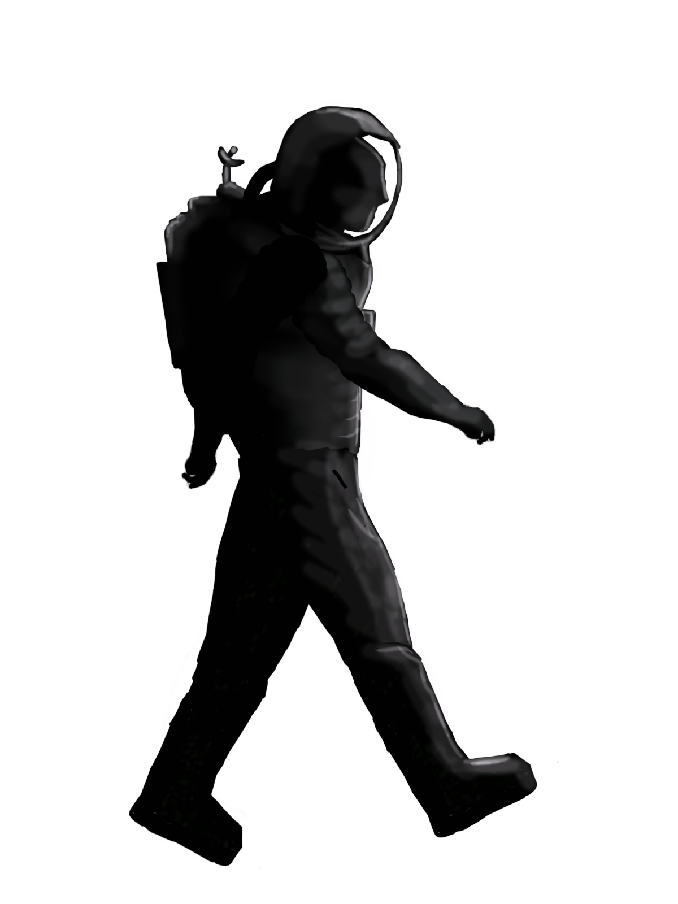

Since the engine is created around simplicity, many of steps are relatively simple, we start the animation engine by being presented with a web page asking for the user to name the animation by typing it into a box and clicking next. This allows the user to add their animation name which will later appear in the top left hand corner of the animation.

10999629_10206149183065659_1028752909_o.jpg

Once that step is completed, the user is then asked to begin customising their own experience by selecting a background, should the user wish to add their own background to the selection of this page, they can add their created image into the file labeled background. Once this is done, type in the name of the file and click next.

10999629_10206149183505670_1854327739_o.jpg

After this stage, the user will be presented with a similar screen in order to select a character, or alternatively to upload their own character. In order to upload their own character, they can either edit one of the predefined characters if they do not wish to attempt the movement animation, or they can add their finished file into the character folder.

This is an example of the predefined character that can be used within the animation engine or can be edited/tailored to the users wants and needs.



The next page details the movement in which the character would take, which is two text boxes. The first text box details to speed that the user would wish the frame rate for the animated character move at, and the second text box requires the starting position that the user would like the character to begin at.

The character will then begin moving from the selected location to the right of the animation and continue walking offscreen.

The next two screens allow the user to input an object which can fall into the scene or creep upwards, the movements and functions have been added in in order to increase the flexibility of the animation engine.   
  
These boxes allow for the user to add in their own images for their objects and select a movement for these objects, as there are more than one of these screens, it means the user can add in a variety of objects called to move in different ways, or allowing the character to move in different ways.  
  
Here, we have an example of one of the preset objects that the user can chose to move or fall.

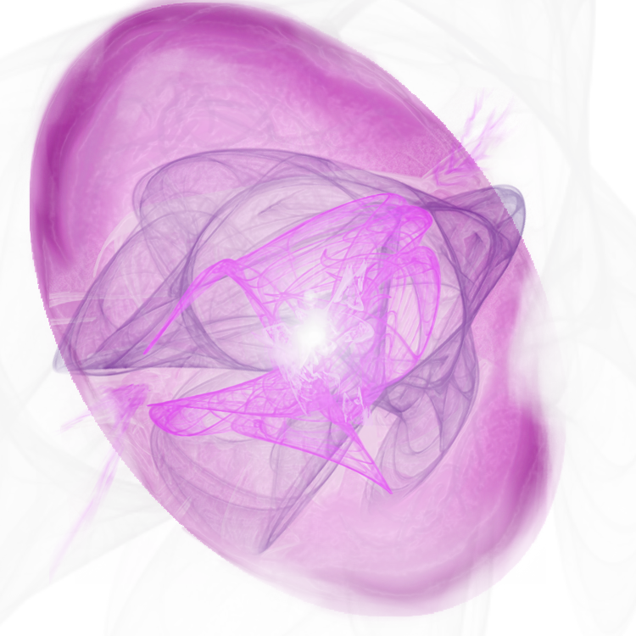

The second to last step is where the user is able to add optional extras, which is where the user can add things such as audio and text dialog to their animation, although instructions can be found above, I’ll repeat them here too.  
  
To add audio, find a related youtube video, we’ve chosen youtube as it allows individual users to upload their own content as well as a wide range of selection from the internet. Once a video has been found, navigate to the embedded link, usually under the share tab and select everything within the quotation marks after the source in declared.   
It will often look like this:  
***src="***[***https://www.youtube.com/embed/wZZ7oFKsKzY***](https://www.youtube.com/embed/wZZ7oFKsKzY)***"***

Once you have this piece of requirement, add this to one of the boxes under extras.

In order to add text dialog, add the text you would like to use to the extras boxe for it to play.

Once the user has filled in all their boxes and is happy to see what their animation will look like, they would just need to fill in the author box and hit next. Then the animation will play.

11221088_10206149184065684_544169507_o.jpg

**Breakdown of work allocation sheet:**

|  |  |  |  |  |  |  |
| --- | --- | --- | --- | --- | --- | --- |
|  | **Rob** | **Zach** | **Chris** | **Becky** | **Elliot** | **Total** |
| Phase 1 | 20 | 20 | 20 | 20 | 20 | 100 |
| Phase 2 | 50 | 0 | 20 | 10 | 20 | 100 |
| Phase 3 | 0 | 10 | 10 | 50 | 30 | 100 |
| Phase 4 | 10 | 50 | 30 | 0 | 10 | 100 |
| Phase 5 | 20 | 20 | 20 | 20 | 20 | 100 |
| **Total** | **100** | **100** | **100** | **100** | **100** |  |

**Glossary of Concepts**

Frames - The different layers of drawing an object used to create an animation

Frame Speed - The speed in which the frames are played in order to create the illusion of movement

Position - The start or end point of an object or character within the animation can be defined as the position

Weight - Sense of gravity that can be added to an object or character

Scale - The size of the image that can be used for the character or object to create a 3d environment using depth afield

Audio - Soundtrack or voice over used in the creation of the animation to create a more engaging animation.